Airline passenger satisfication
1. Project Overview and Objective

This project involves cleaning, transforming, and analysing raw data using Excel and creating an interactive Power BI dashboard to derive meaningful business insights.

The main objective is to demonstrate data pre-processing techniques using Excel and an interactive Power BI dashboard visualization to make informed decisions.

2. Data Sources
- Source Description and Timeline: Google Dataset Search and 2025-2026
- Domain: Commerce

3. Problem Statement
- To analyse sales performance across regions and products to identify top-performing areas and profit trends.
- To study crop production patterns across states and years for better agricultural planning.
- To evaluate employee performance and attrition factors for improved HR decision-making.
- To understand customer purchasing behavior to enhance marketing and retention strategies

4. Attribute (Column /Features) Details: (Sample)
Attribute Name | Data Type | Description
ID | Integer / String | Unique identifier for each employee
Gender | String (Text) | male/female
Age | Numeric (Integer) | Age of the employee in years
Department | Categorical | Department where employee works

5. Tools & Technologies
- Excel: Data cleaning, transformation, and Pivot Tables.
- Power BI: Data modelling, DAX calculations, visualization, and interactive dashboard creation

Tasks Performed:
- Data Cleaning & Transformation: Removed duplicates, handled missing values, standardized formats, and created calculated fields.
- 1.Arrival Delay
- blank cell is replace with median 15.09112884 in to whole number as 15
- Type of Travel =proper(trim(clean(E2)))
- 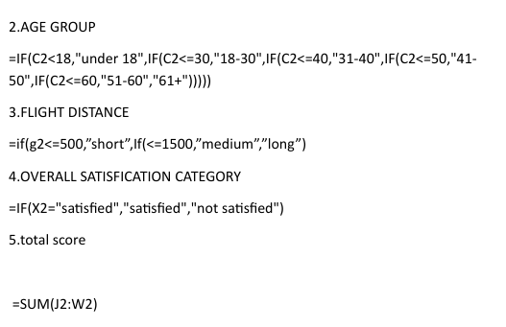
- Filtering & Sorting: Organized data to focus on relevant records.
- Pivot Tables: Generated Pivot Tables for data summarisation and initial insights.
- 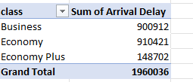
- 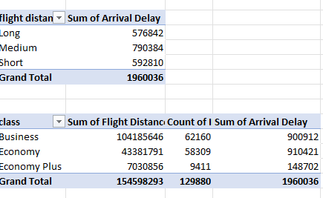
- 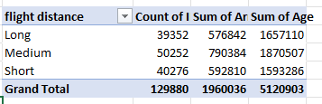

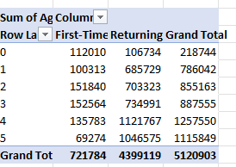
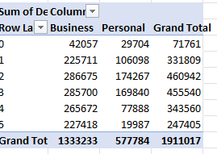

7. Data Modelling and DAX (Power BI)
- Data Model: Established relationships between tables, defined cardinality, and created lookup tables where necessary.
SCREENSHOT OF DATA MODELLING
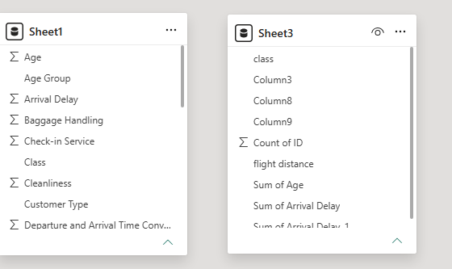

8. Analysis and Visualizations (Power BI)
Dashboard Features:
- Multiple Visualizations based on problem statement: Bar charts, line charts, pie charts, cards, and tables to communicate insights. (List Out)
- Make your Report interactive Layout using Drill-down, Filters and slicers
- Bookmarks, Clear Titles for each visuals & Labels is must.
- Create a consolidated Report /Dashboard.
SCREENSHOT OF DASHBOARD /REPORT
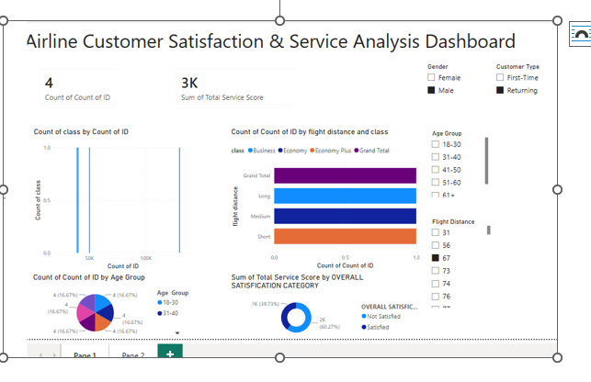

9. Insights & Conclusions
- Key Findings: Summarize trends, patterns, or anomalies identified in the data
- Provide the analysis insights:
Descriptive: The dashboard summarizes customer satisfaction, service scores, age groups, travel classes, and flight-distance categories.
Diagnostic: The analysis helps identify factors and customer segments associated with satisfaction and dissatisfaction.
Predictive: Existing satisfaction and service-score patterns can help identify customer groups that may experience lower satisfaction.
Prescriptive: The airline can use these insights to improve service quality, address weaker areas, and enhance the overall customer experience.
10. Conclusions
The integration of Excel and Power BI proved effective for end-to-end data analysis, from raw data to visual reporting.
